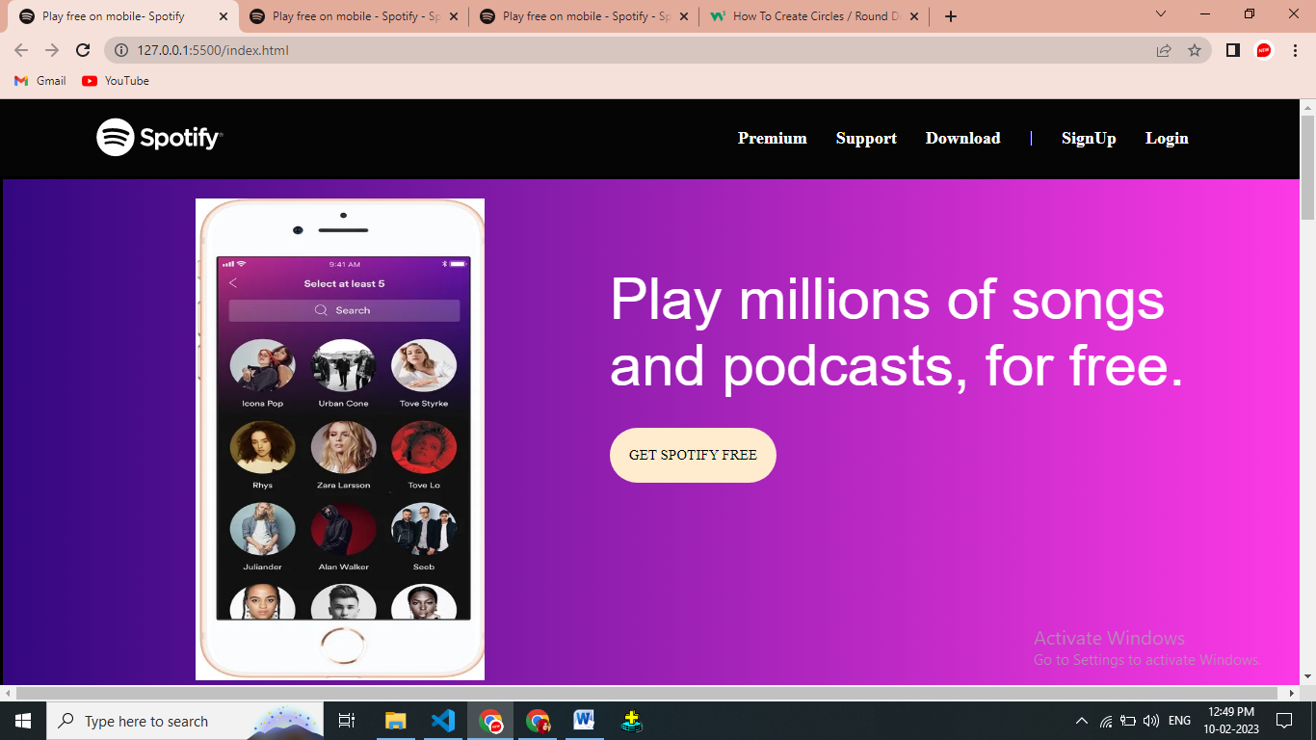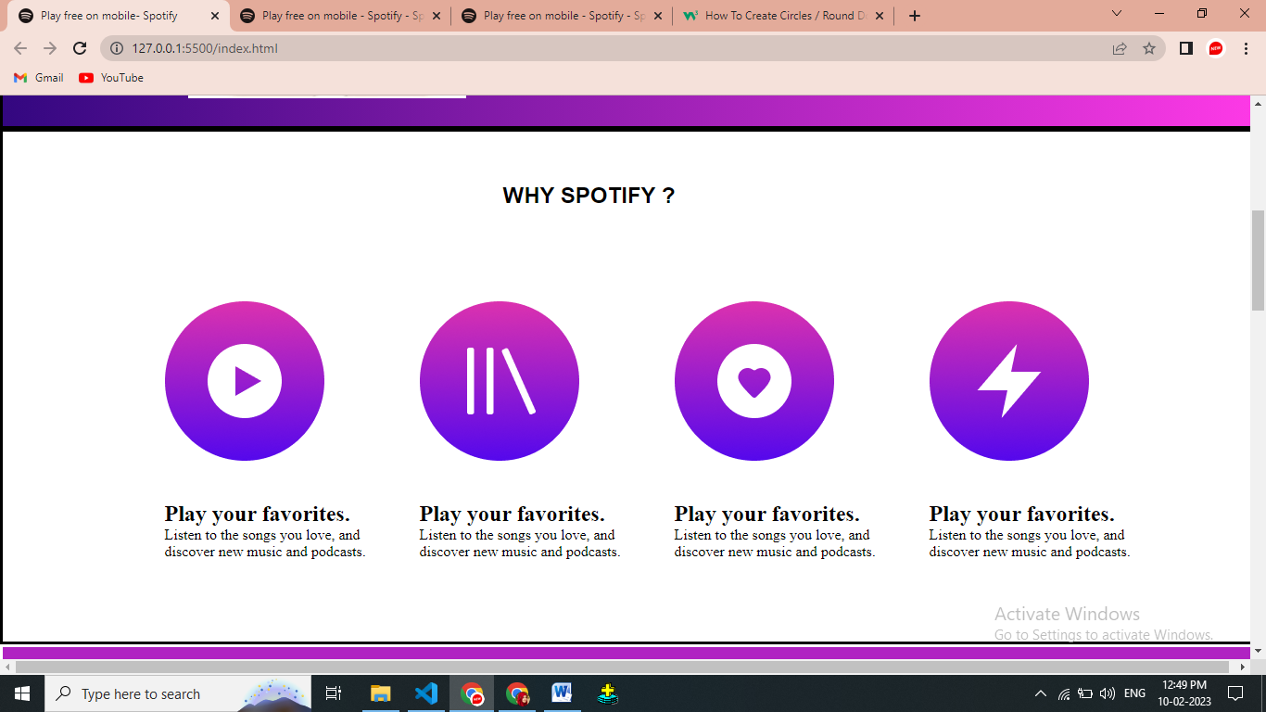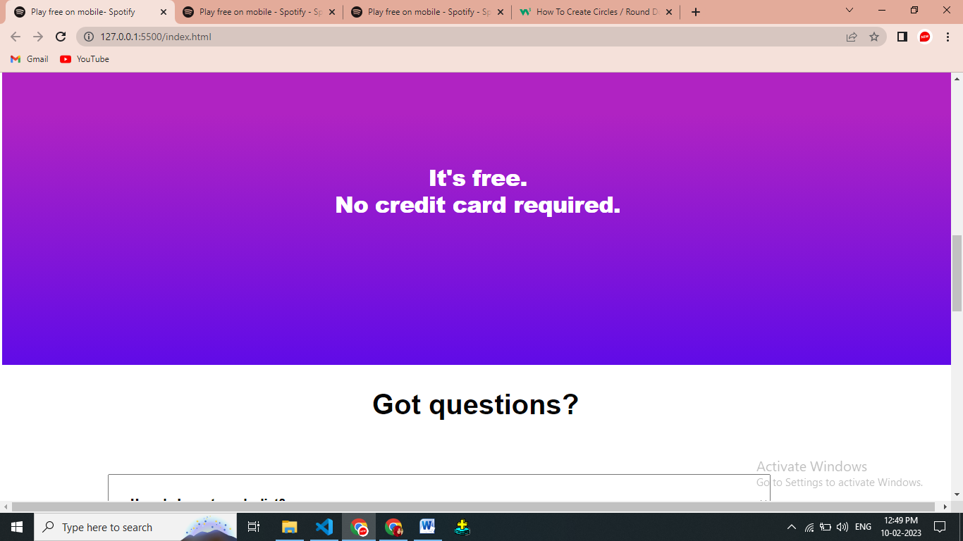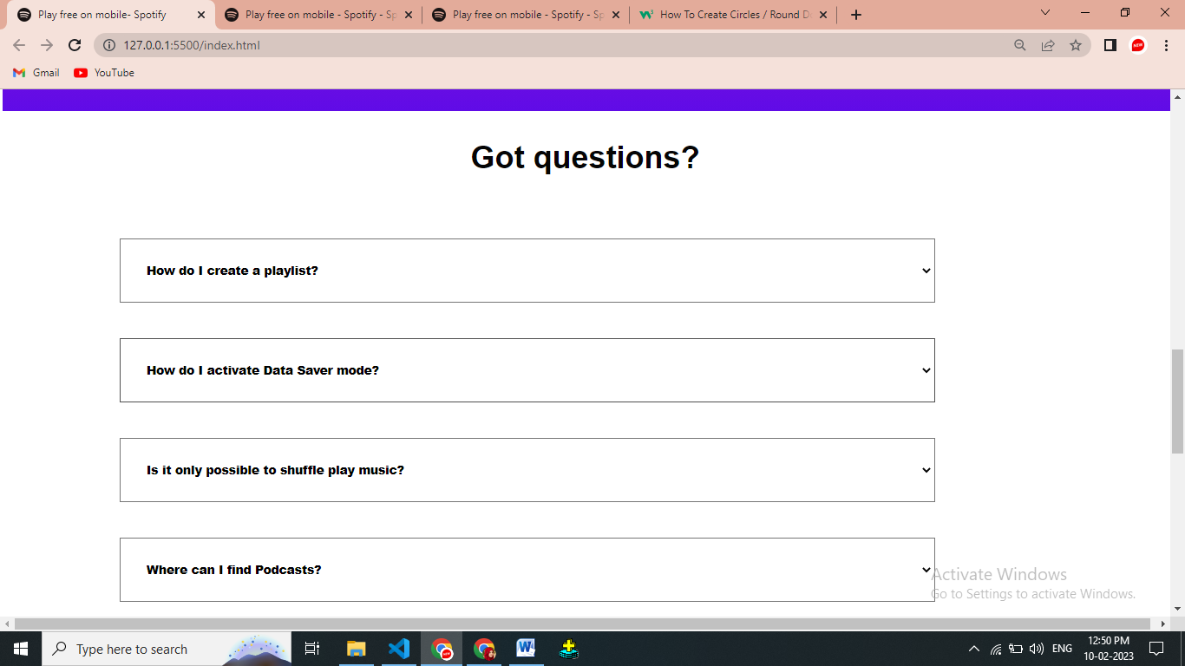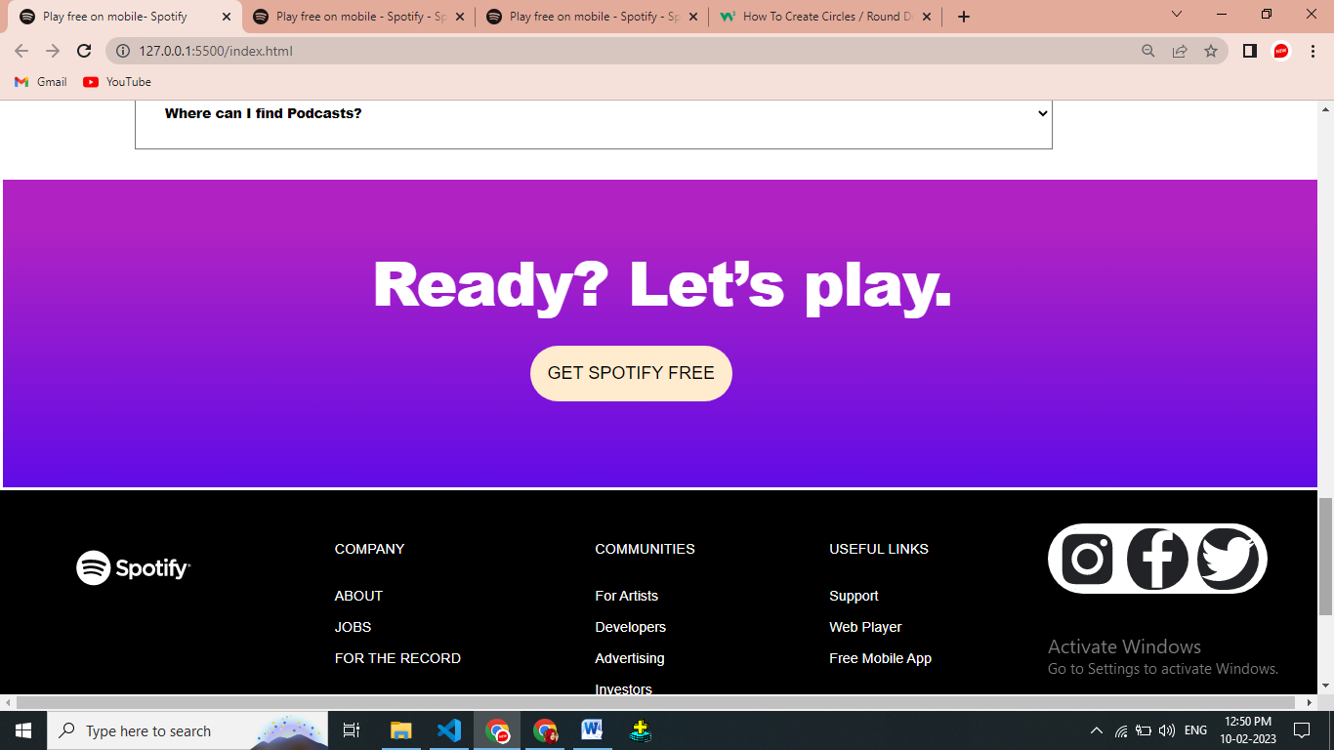

Index.html

<!DOCTYPE html>

<html lang="en">

<head>

<meta charset="UTF-8">

<meta http-equiv="X-UA-Compatible" content="IE=edge">

<meta name="viewport" content="width=device-width, initial-scale=1.0">

<title>Play free on mobile- Spotify</title>

<link rel="icon" href="./favicon/favicon.png">

<link rel="stylesheet" href="style.css">

</head>

<body>

<div class="NavbarContainer">

<div class="MarginAll">

<div class="SpotifyLogo">

<a href="./index.html"></a>

<svg viewBox="0 0 63 20" xmlns="http://www.w3.org/2000/svg" preserveAspectRatio="xMidYMin meet">

<g fill-rule="evenodd" class="svelte-1gcdbl9">

<path

d="M61.842 9.506a1.02 1.02 0 0 1-1.023-1.024c0-.562.453-1.03 1.029-1.03a1.02 1.02 0 0 1 1.023 1.024 1.03 1.03 0 0 1-1.029 1.03m.006-1.952a.915.915 0 0 0-.922.928c0 .51.394.921.916.921a.916.916 0 0 0 .922-.927.908.908 0 0 0-.916-.922m.226 1.027l.29.406h-.244l-.26-.372h-.225v.372h-.204V7.912h.48c.249 0 .413.128.413.343 0 .176-.102.284-.25.326m-.172-.485h-.267v.34h.267c.133 0 .212-.065.212-.17 0-.11-.08-.17-.212-.17m-12.804-3.52a1.043 1.043 0 1 0-.001 2.086 1.043 1.043 0 0 0 0-2.087m.72 2.89h-1.454a.107.107 0 0 0-.106.107v6.346c0 .06.047.107.106.107h1.455a.107.107 0 0 0 .107-.107V7.572a.107.107 0 0 0-.107-.107m3.233.006v-.2c0-.592.227-.856.736-.856.303 0 .546.06.82.152a.106.106 0 0 0 .14-.102V5.24a.107.107 0 0 0-.076-.102 3.993 3.993 0 0 0-1.21-.174c-1.343 0-2.053.757-2.053 2.188v.308h-.699a.107.107 0 0 0-.107.106v1.257c0 .059.048.107.107.107h.699v4.99c0 .058.047.106.106.106h1.455a.107.107 0 0 0 .106-.107v-4.99h1.358l2.081 4.99c-.236.523-.468.628-.785.628-.257 0-.527-.077-.803-.228a.109.109 0 0 0-.084-.008.106.106 0 0 0-.063.058l-.493 1.081a.106.106 0 0 0 .045.138c.515.279.98.398 1.554.398 1.074 0 1.668-.5 2.191-1.847L60.6 7.617a.106.106 0 0 0-.099-.146h-1.514a.107.107 0 0 0-.1.072l-1.552 4.431-1.7-4.434a.106.106 0 0 0-.099-.069h-2.485m-5.577-.006h-1.6V5.828a.106.106 0 0 0-.107-.106h-1.455a.107.107 0 0 0-.106.106v1.637h-.7a.106.106 0 0 0-.106.107v1.25c0 .059.048.107.106.107h.7v3.234c0 1.308.65 1.97 1.934 1.97.522 0 .954-.107 1.362-.338a.106.106 0 0 0 .054-.093v-1.19a.106.106 0 0 0-.154-.096c-.28.141-.551.206-.854.206-.467 0-.675-.211-.675-.686V8.929h1.6a.106.106 0 0 0 .107-.107v-1.25a.106.106 0 0 0-.106-.107m-7.671-.133c-1.96 0-3.497 1.51-3.497 3.437 0 1.907 1.526 3.4 3.473 3.4 1.967 0 3.508-1.504 3.508-3.424 0-1.914-1.53-3.413-3.484-3.413m0 5.362c-1.043 0-1.83-.838-1.83-1.95 0-1.115.76-1.924 1.806-1.924 1.05 0 1.84.838 1.84 1.95 0 1.115-.763 1.924-1.816 1.924m-7.014-5.362c-.82 0-1.492.323-2.046.984v-.744a.107.107 0 0 0-.106-.107h-1.455a.107.107 0 0 0-.106.107v8.27c0 .058.048.106.106.106h1.455a.107.107 0 0 0 .106-.106v-2.61c.555.621 1.227.925 2.046.925 1.522 0 3.063-1.172 3.063-3.412s-1.54-3.413-3.063-3.413m1.372 3.413c0 1.14-.703 1.937-1.709 1.937-.995 0-1.745-.833-1.745-1.937s.75-1.937 1.745-1.937c.99 0 1.71.814 1.71 1.937m-8.437-1.81c-1.624-.388-1.913-.66-1.913-1.231 0-.54.508-.903 1.264-.903.732 0 1.459.275 2.22.843a.107.107 0 0 0 .15-.023l.794-1.119a.107.107 0 0 0-.02-.144c-.906-.728-1.927-1.081-3.12-1.081-1.755 0-2.98 1.052-2.98 2.559 0 1.615 1.057 2.187 2.884 2.628 1.554.358 1.817.658 1.817 1.195 0 .594-.53.963-1.385.963-.948 0-1.721-.32-2.587-1.068a.11.11 0 0 0-.078-.026.105.105 0 0 0-.073.038l-.89 1.058a.105.105 0 0 0 .011.148 5.303 5.303 0 0 0 3.581 1.373c1.89 0 3.112-1.033 3.112-2.631 0-1.351-.807-2.098-2.787-2.58M9.507.305a9.41 9.41 0 1 0 0 18.82 9.41 9.41 0 0 0 0-18.82m4.316 13.572a.586.586 0 0 1-.807.195c-2.21-1.35-4.99-1.655-8.266-.907a.586.586 0 1 1-.261-1.143c3.584-.82 6.659-.467 9.139 1.049.276.169.363.53.195.806m1.15-2.562a.734.734 0 0 1-1.008.242c-2.529-1.555-6.385-2.005-9.377-1.097a.735.735 0 0 1-.426-1.404c3.418-1.037 7.666-.534 10.57 1.25a.734.734 0 0 1 .242 1.01m.1-2.669C12.04 6.846 7.036 6.68 4.141 7.56a.88.88 0 1 1-.511-1.684c3.323-1.01 8.849-.814 12.34 1.258a.88.88 0 0 1-.898 1.514">

</path>

</g>

</svg></a>

</div>

<div class="NavbarList">

<ul>

<li><a>Premium</a> </li>

<li><a>Support</a></li>

<li><a>Download</a></li>

<li>|</li>

<li><a>SignUp</a></li>

<li><a>Login</a></li>

</ul>

</div>

</div>

</div>

<div id="bd">

<div id="img"><img src="./a.jpg" alt="" style="height: 500px; width: 300px; margin-left: 200px;"></div>

<div id="txt">

<div id="t1">Play millions of songs <br> and podcasts, for free.</div>

<div id="btn">GET SPOTIFY FREE</div>

</div>

</div>

<div id="f1">

<div id="h2">

<h2>WHY SPOTIFY ?</h2>

</div>

<div id="c1">

<div class="z1" id="cc1">

<div id="img1"><img src="./1.png" alt="">

<div>

<P class="txt2">

<h2> Play your favorites.</h2>Listen to the songs you love, and discover new music and podcasts.

</P>

</div>

</div>

</div>

<div class="z1" id="cc2">

<div id="img2"><img src="./2.png" alt="">

<div>

<P class="txt2">

<h2> Play your favorites.</h2>Listen to the songs you love, and discover new music and podcasts.

</P>

</div>

</div>

</div>

<div class="z1" id="cc3">

<div id="img3"><img src="./3.png" alt="">

<div>

<P class="txt2">

<h2> Play your favorites.</h2>Listen to the songs you love, and discover new music and podcasts.

</P>

</div>

</div>

</div>

<div class="z1" id="cc4">

<div id="img4"><img src="./4.png" alt="">

<div>

<P class="txt2">

<h2> Play your favorites.</h2>Listen to the songs you love, and discover new music and podcasts.

</P>

</div>

</div>

</div>

</div>

</div>

<div id="f2">

<h1 id="h1">It's free. <br> No credit card required.</h1>

</div>

<div id="f3">

<h2 id="txt3">Got questions?</h2><br><br>

<div id="list">

<ul>

<li class="lis"><select name="" id="opt">

<option value="">How do I create a playlist?</option>

</select></li>

<li class="lis"><select name="" id="opt">

<option value="">How do I activate Data Saver mode?</option>

</select></li>

<li class="lis"><select name="" id="opt">

<option value="">Is it only possible to shuffle play music?</option>

</select></li>

<li class="lis"><select name="" id="opt">

<option value="">Where can I find Podcasts?</option>

</select></li>

</ul>

</div>

</div>

<div id="f4">

<h1 id="h">Ready? Let’s play.</h1>

<div id="btn2">GET SPOTIFY FREE</div>

</div>

<div id="f5">

<div class="ftr" id="co1">

<div class="SpotifyLogo">

<a href="./index.html"></a>

<svg viewBox="0 0 63 20" xmlns="http://www.w3.org/2000/svg" preserveAspectRatio="xMidYMin meet">

<g fill-rule="evenodd" class="svelte-1gcdbl9">

<path

d="M61.842 9.506a1.02 1.02 0 0 1-1.023-1.024c0-.562.453-1.03 1.029-1.03a1.02 1.02 0 0 1 1.023 1.024 1.03 1.03 0 0 1-1.029 1.03m.006-1.952a.915.915 0 0 0-.922.928c0 .51.394.921.916.921a.916.916 0 0 0 .922-.927.908.908 0 0 0-.916-.922m.226 1.027l.29.406h-.244l-.26-.372h-.225v.372h-.204V7.912h.48c.249 0 .413.128.413.343 0 .176-.102.284-.25.326m-.172-.485h-.267v.34h.267c.133 0 .212-.065.212-.17 0-.11-.08-.17-.212-.17m-12.804-3.52a1.043 1.043 0 1 0-.001 2.086 1.043 1.043 0 0 0 0-2.087m.72 2.89h-1.454a.107.107 0 0 0-.106.107v6.346c0 .06.047.107.106.107h1.455a.107.107 0 0 0 .107-.107V7.572a.107.107 0 0 0-.107-.107m3.233.006v-.2c0-.592.227-.856.736-.856.303 0 .546.06.82.152a.106.106 0 0 0 .14-.102V5.24a.107.107 0 0 0-.076-.102 3.993 3.993 0 0 0-1.21-.174c-1.343 0-2.053.757-2.053 2.188v.308h-.699a.107.107 0 0 0-.107.106v1.257c0 .059.048.107.107.107h.699v4.99c0 .058.047.106.106.106h1.455a.107.107 0 0 0 .106-.107v-4.99h1.358l2.081 4.99c-.236.523-.468.628-.785.628-.257 0-.527-.077-.803-.228a.109.109 0 0 0-.084-.008.106.106 0 0 0-.063.058l-.493 1.081a.106.106 0 0 0 .045.138c.515.279.98.398 1.554.398 1.074 0 1.668-.5 2.191-1.847L60.6 7.617a.106.106 0 0 0-.099-.146h-1.514a.107.107 0 0 0-.1.072l-1.552 4.431-1.7-4.434a.106.106 0 0 0-.099-.069h-2.485m-5.577-.006h-1.6V5.828a.106.106 0 0 0-.107-.106h-1.455a.107.107 0 0 0-.106.106v1.637h-.7a.106.106 0 0 0-.106.107v1.25c0 .059.048.107.106.107h.7v3.234c0 1.308.65 1.97 1.934 1.97.522 0 .954-.107 1.362-.338a.106.106 0 0 0 .054-.093v-1.19a.106.106 0 0 0-.154-.096c-.28.141-.551.206-.854.206-.467 0-.675-.211-.675-.686V8.929h1.6a.106.106 0 0 0 .107-.107v-1.25a.106.106 0 0 0-.106-.107m-7.671-.133c-1.96 0-3.497 1.51-3.497 3.437 0 1.907 1.526 3.4 3.473 3.4 1.967 0 3.508-1.504 3.508-3.424 0-1.914-1.53-3.413-3.484-3.413m0 5.362c-1.043 0-1.83-.838-1.83-1.95 0-1.115.76-1.924 1.806-1.924 1.05 0 1.84.838 1.84 1.95 0 1.115-.763 1.924-1.816 1.924m-7.014-5.362c-.82 0-1.492.323-2.046.984v-.744a.107.107 0 0 0-.106-.107h-1.455a.107.107 0 0 0-.106.107v8.27c0 .058.048.106.106.106h1.455a.107.107 0 0 0 .106-.106v-2.61c.555.621 1.227.925 2.046.925 1.522 0 3.063-1.172 3.063-3.412s-1.54-3.413-3.063-3.413m1.372 3.413c0 1.14-.703 1.937-1.709 1.937-.995 0-1.745-.833-1.745-1.937s.75-1.937 1.745-1.937c.99 0 1.71.814 1.71 1.937m-8.437-1.81c-1.624-.388-1.913-.66-1.913-1.231 0-.54.508-.903 1.264-.903.732 0 1.459.275 2.22.843a.107.107 0 0 0 .15-.023l.794-1.119a.107.107 0 0 0-.02-.144c-.906-.728-1.927-1.081-3.12-1.081-1.755 0-2.98 1.052-2.98 2.559 0 1.615 1.057 2.187 2.884 2.628 1.554.358 1.817.658 1.817 1.195 0 .594-.53.963-1.385.963-.948 0-1.721-.32-2.587-1.068a.11.11 0 0 0-.078-.026.105.105 0 0 0-.073.038l-.89 1.058a.105.105 0 0 0 .011.148 5.303 5.303 0 0 0 3.581 1.373c1.89 0 3.112-1.033 3.112-2.631 0-1.351-.807-2.098-2.787-2.58M9.507.305a9.41 9.41 0 1 0 0 18.82 9.41 9.41 0 0 0 0-18.82m4.316 13.572a.586.586 0 0 1-.807.195c-2.21-1.35-4.99-1.655-8.266-.907a.586.586 0 1 1-.261-1.143c3.584-.82 6.659-.467 9.139 1.049.276.169.363.53.195.806m1.15-2.562a.734.734 0 0 1-1.008.242c-2.529-1.555-6.385-2.005-9.377-1.097a.735.735 0 0 1-.426-1.404c3.418-1.037 7.666-.534 10.57 1.25a.734.734 0 0 1 .242 1.01m.1-2.669C12.04 6.846 7.036 6.68 4.141 7.56a.88.88 0 1 1-.511-1.684c3.323-1.01 8.849-.814 12.34 1.258a.88.88 0 0 1-.898 1.514">

</path>

</g>

</svg></a>

</div>

</div>

<div class="ftr" id="co2">COMPANY <br><br><br>About<br> <br> Jobs<br> <br> For the Record</div>

<div class="ftr" id="co3">COMMUNITIES <br><br><br>

For Artists<br> <br>

Developers<br><br>

Advertising<br><br>

Investors<br><br>

Vendors</div>

<div class="ftr" id="co4">USEFUL LINKS <br><br><br>

Support<br><br>

Web Player<br><br>

Free Mobile App</div>

<div class="ftr" id="co5">

<img src="./indta.svg" alt="" class="ftim" id="ins">

<img src="./fb.svg" alt="" class="ftim" id="face">

<img src="./twit.svg" alt="" class="ftim" id="tw">

</div>

</div>

</body>

</html>

Style.css

\* {

padding: 0;

margin: 0;

}

.MarginAll {

margin: 0 100px;

display: flex;

align-items: center;

flex-direction: row;

justify-content: space-between;

width: 100%;

}

.SpotifyLogo {

width: 132px;

height: 41.89px;

filter: grayscale(1);

color: #fff;

}

.SpotifyLogo .svelte-1gcdbl9 {

fill: currentColor;

}

.SpotifyLogo a {

color: #fff;

}

.NavbarContainer {

height: 80px;

width: 100%;

background-color: #050505;

display: flex;

align-items: center;

flex-direction: row;

}

.NavbarContainer ul {

display: flex;

color: #fff;

}

.NavbarList ul li a {

text-decoration: none;

font-size: 18px;

font-weight: 700;

}

.NavbarList ul li {

list-style: none;

margin: 0px 15px;

}

.NavbarList ul li a:hover {

color: green;

}

#bd {

background-color: purple;

background-image: linear-gradient(to right, rgb(51, 7, 128), rgb(253, 57, 230));

height: 550px;

width: 100%;

border: solid;

margin: 0 auto;

}

#img {

display: inline-block;

margin-top: 20px;

align-items: start;

height: 450px;

width: 500px;

vertical-align: middle;

/\* border:solid green; \*/

position: relative;

}

#txt {

display: inline-block;

/\* margin-top: 50px; \*/

height: 450px;

width: 839px;

/\* background-color: yellow; \*/

align-items: end;

color: #a54f4f;

vertical-align: middle;

}

#t1 {

margin-top: 80px;

margin-left: 15%;

font-family: Helvetica, Arial, sans-serif;

font-size: 60px;

box-sizing: border-box;

color: #fff;

}

#btn {

box-sizing: border-box;

font-size: 15px;

color: black;

text-decoration: bold;

/\* font-weight: 00; \*/

margin-left: 15%;

margin-top: 30px;

background-color: blanchedalmond;

/\* border: 0px; \*/

border-radius: 500px;

padding: 20px;

display: inline-block;

position: relative;

text-align: center;

text-decoration: none;

}

#f1 {

/\* background-color: purple; \*/

/\* background-image: linear-gradient(to right, rgb(51, 7, 128) , rgb(253, 57, 230)); \*/

height: 550px;

width: 100%;

border: solid;

margin: 0 auto;

}

#h2 {

align-items: right;

flex-direction: row;

/\* margin: 40%; \*/

padding-left: 40%;

color: #000000;

float: center;

margin-top: 55px;

font-family: sans-serif;

font-weight: bolder;

}

#c1{

/\* border: 1px solid; \*/

align-items:flex-start;

height: 300px;

margin-top: 50px;

width: 1100px;

/\* border: 1px solid red; \*/

margin: 0 auto;

margin-top: 100px;

display: flex;

justify-content: space-around;

}

.z1{

height: 400px;

width: 400px;

/\* border: 1px solid; \*/

padding-left: 50px;

/\* background-color: hotpink; \*/

}

.txt2{

margin-top: 40px;

color: #090909;

font-size: large;

font-family: 'Courier New', Courier, monospace;

}

#f2{

height: 420px;

width: 100%;

border: solid;

margin: 0 auto;

color: white;

font-family: var(--font-family,spotify-circular),Helvetica,Arial,sans-serif;

background-image: linear-gradient(rgb(176, 35, 194) 15%, rgb(96, 11, 231));

}

#f3{

height: 650px;

/\* width: 100%; \*/

border: solid;

margin: 0 auto;

color: white;

font-family: var(--font-family,spotify-circular),Helvetica,Arial,sans-serif;

/\* background-image: linear-gradient(rgb(176, 35, 194) 15%, rgb(96, 11, 231)); \*/

}

.list{

/\* list-style: none; \*/

margin-left: 100px;

/\* align-items: center; \*/

align-content: center;

/\* flex: content; \*/

/\* display: inline-flex; \*/

justify-content:center ;

/\* padding: 0px; \*/

font-family: spotify-circular,Helvetica,Arial,sans-serif;

}

#lis{

width: 80%;

align-items: center;

/\* height: ; \*/

color: aqua;

border: 1px solid black;

font-family: spotify-circular,Helvetica,Arial,sans-serif;

}

#txt3{

font-size: 40px;

line-height: 46px;

/\* box-sizing: border-box; \*/

font-family:Helvetica,Arial,sans-serif;

text-align: center;

color: #050505;

margin-top: 2%;

}

#opt{

padding-top: 10px;

padding-bottom: 10px;

height: 10%;

width: 70%;

/\* align-items: center; \*/

padding: 2%;

margin-left: 150px;

margin-top: 3%;

font-family: Helvetica,Arial,sans-serif;

font-size: 15px;

font-weight: 900;

}

#f4{

height: 350px;

width: 100%;

border: solid;

margin: 0 auto;

color: white;

font-family: var(--font-family,spotify-circular),Helvetica,Arial,sans-serif;

background-image: linear-gradient(rgb(176, 35, 194) 15%, rgb(96, 11, 231));

}

#h1{

text-align: center;

margin-top: 10%;

padding-right: 20px;

font-weight: 900;

letter-spacing: -0.02em;

line-height: 1.2;

padding: 0px 15px 80px;

}

#h{

font-weight: 900;

letter-spacing: -0.02em;

line-height: 1.2;

text-align: center;

margin-top: 5%;

/\* font-weight: 1200; \*/

/\* font-size: xx-large; \*/

font-size: 70px;

}

#btn2 {

box-sizing: border-box;

font-size: 20px;

color: black;

text-decoration: bold;

/\* font-weight: 00; \*/

margin-left: 40%;

margin-top: 30px;

background-color: blanchedalmond;

/\* border: 0px; \*/

border-radius: 500px;

padding: 20px;

display: inline-block;

position: relative;

text-align: center;

text-decoration: none;

font-family: var(--font-family,spotify-circular),Helvetica,Arial,sans-serif;

}

#f5{

height: 550px;

width: 100%;

border: #fefdfd;

/\* background-color: #000000; \*/

margin: 0 auto;

/\* margin-top: 100px; \*/

padding-top: 38px;

display: flex;

justify-content: space-between;

background-color:black;

}

.ftr{

margin: 0 auto;

margin-top: 100px;

display: flex;

/\* background-color:white; \*/

}

#co1{

margin: 0 auto;

padding: 30px;

color: white;

}

#co2{

margin: 0 auto;

padding: 20px;

color: white;

/\* font-weight: 900; \*/

/\* letter-spacing: .08em; \*/

text-transform: uppercase;

font-size: 16px;

font-family: CircularSp,spotify-circular,Helvetica,Arial,sans-serif;

/\* font-weight: 400;margin-inline-start: 40px; \*/

}

#co3{

margin: 0 auto;

padding: 20px;

color: white;font-family: CircularSp,spotify-circular,Helvetica,Arial,sans-serif;

}

#co4{

margin: 0 auto;

padding: 20px;

color: white;font-family: CircularSp,spotify-circular,Helvetica,Arial,sans-serif;

}

#co5{

margin: 0 auto;

padding: 0px;

align-items: center;

/\* color: white; \*/

background-color: white;

border-radius: 50px;

width: 250px;

height: 80px;

}

.ftim{

width: 70px;

height: 70px;

display: block;

list-style-type: disc;

margin-block-start: 1em;

margin-block-end: 1em;

margin-inline-start: 0px;

margin-inline-end: 0px;

padding-inline-start: 10px;

color: white;

justify-content: space-between;

border-radius: 50px;

}

/\* #ins{

display: block;

width: 40px;

height: 50px;

color: white;

} \*/

/\* #cc1{

order: 1;

order: -2;

} \*/

/\* #img1{

display: flex;

float: center;

} \*/